**LAB 4 Advanced Software Engineering**

**SOAP services with Web Client**

As given in the tutorials a soap service is created in the visual studio using C# language which gives takes input as string and gives output the number of characters in the string. All the code and steps is shown in the screenshots below:

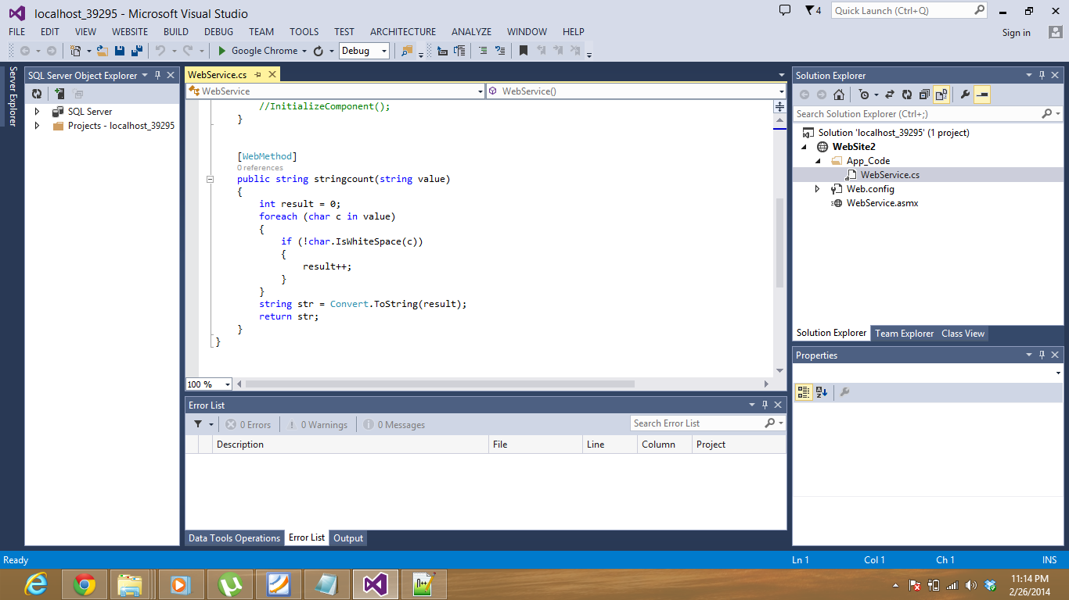

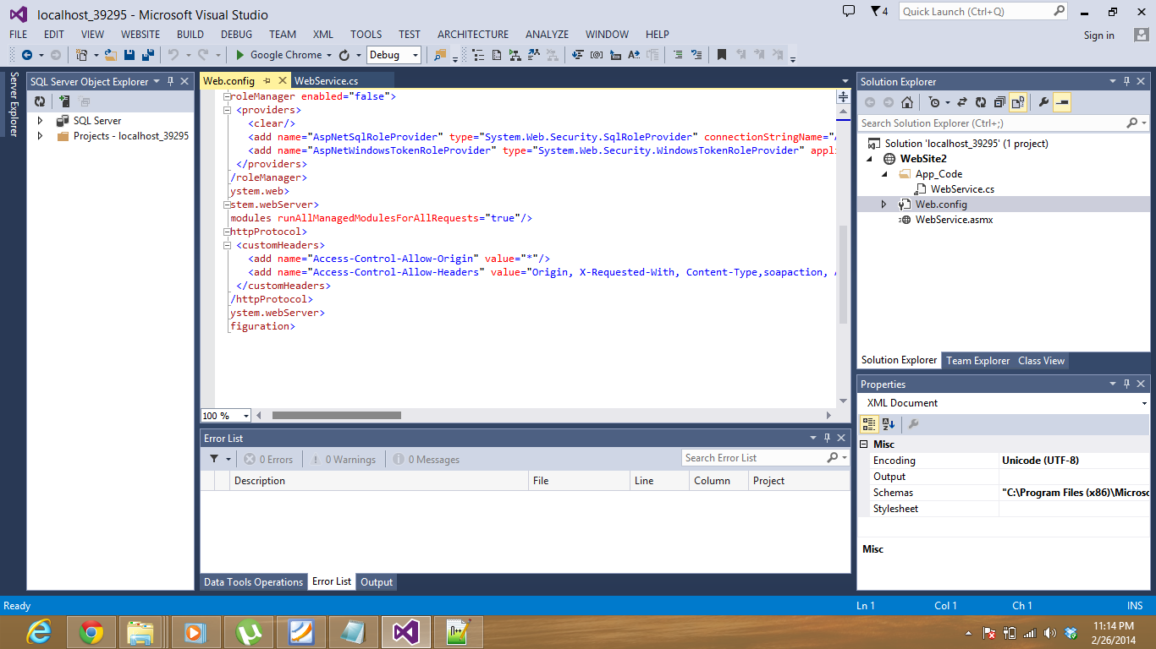

The service is viewed in browser as: 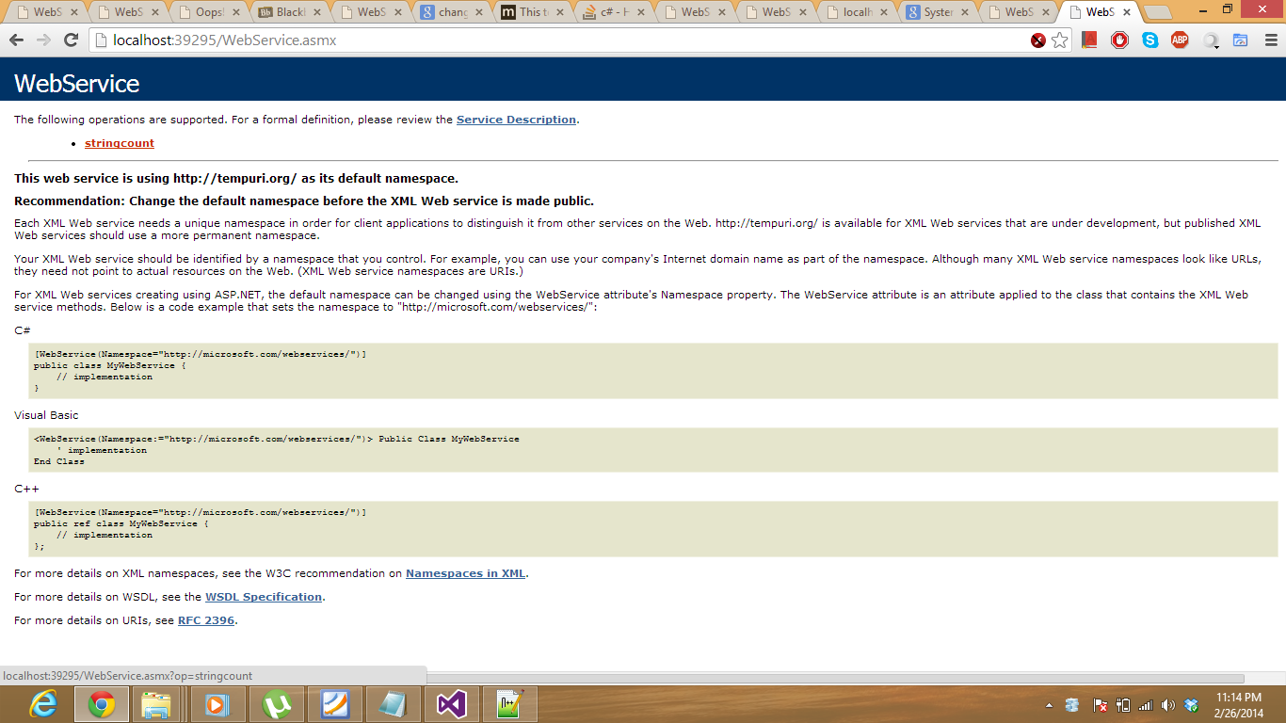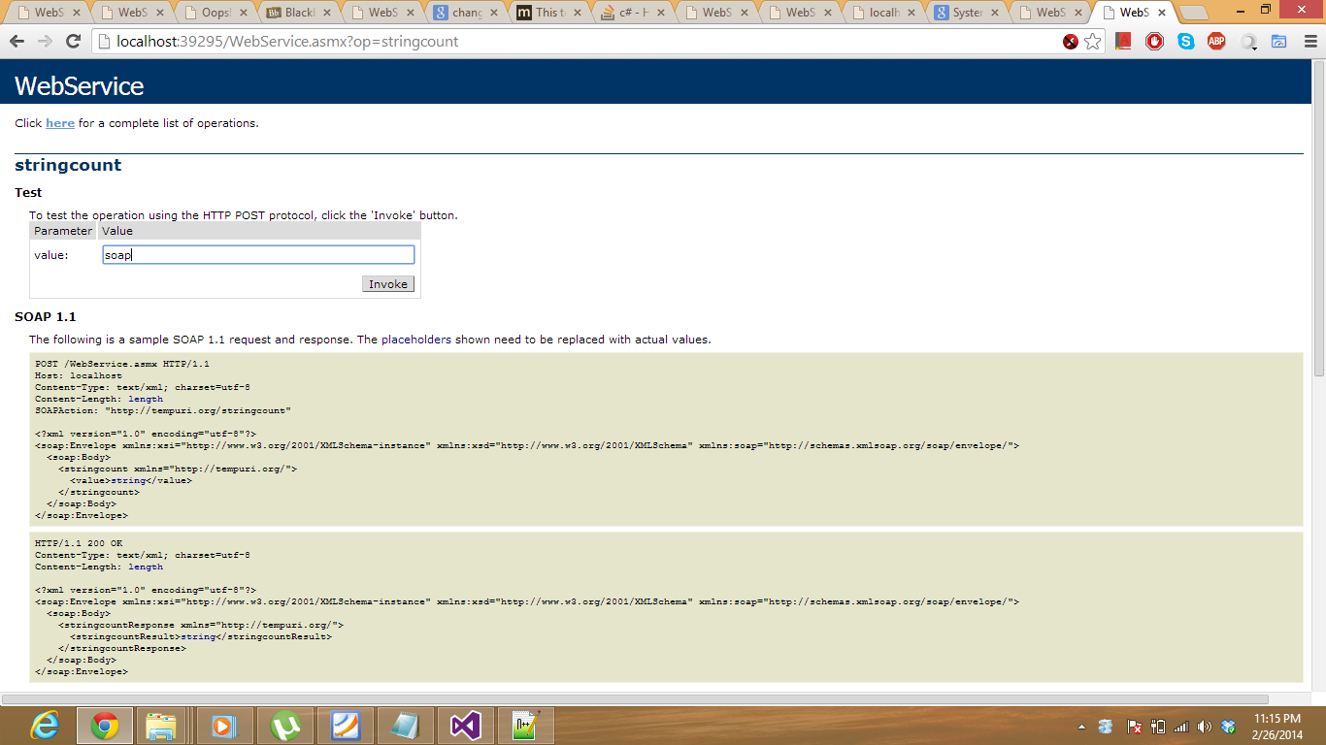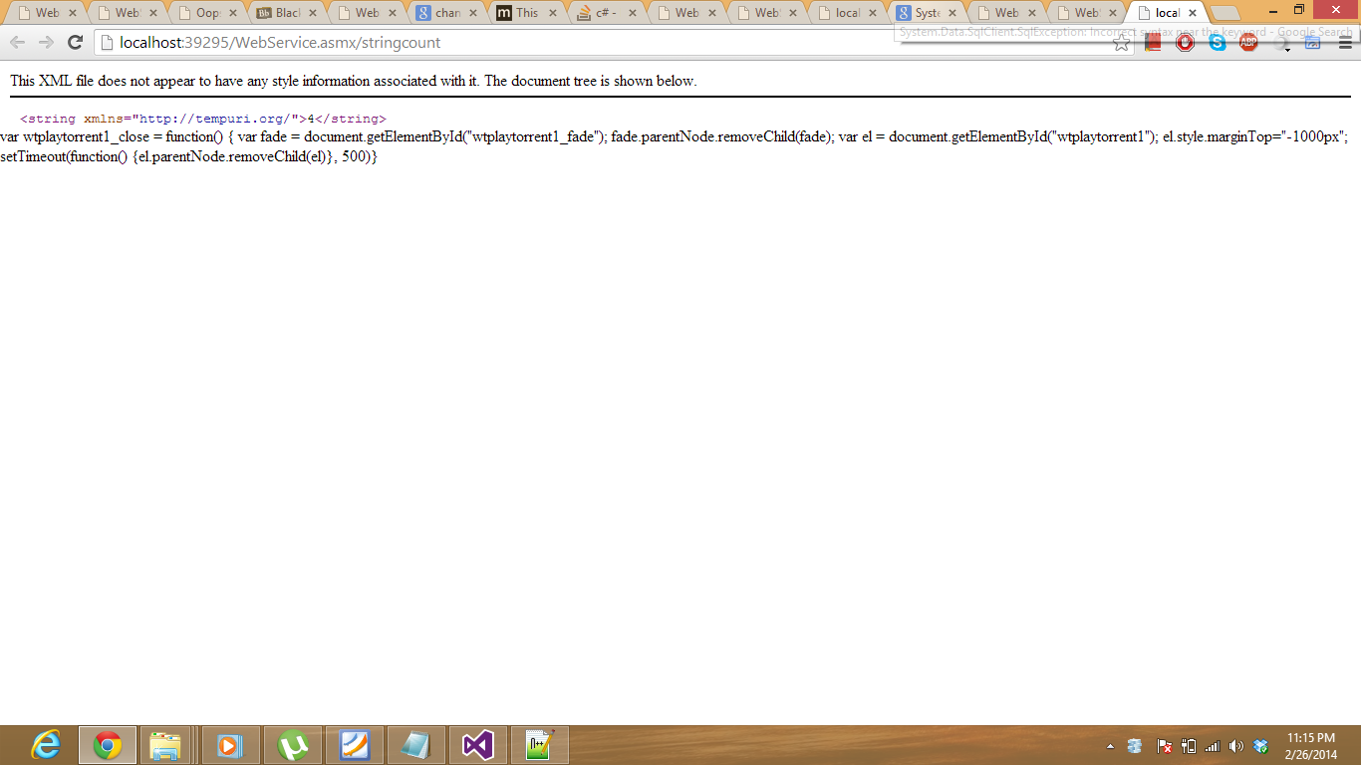

Using the web client developed using Jquery and SOAP API the web service is accessed and consumed as shown.

